**Renal anatomy & function**

* Function:
  + **Waste**: filter waste from blood
    - Toxic
    - Metabolic wastes
    - Foreign compounds
  + **Osmoregulation**: regulation body’s water and solute composition
    - pH
    - ECF ion concentrations
  + **Endocrine**: production of hormones (renin; erythropoietin) and Vitamin D
* **Kidneys**: urine forming organs
  + Intimately associated with the **adrenal glands**
  + **Reserve capacity**: lose ~ ¾ of kidney function before homeostasis is affected
  + Urine goes through kidney **=> ureters** => bladder => **urethra**
    - All **smooth muscle**
    - bladder **distensible**
    - urethra **epithelial-lined**, for male **dual function** (urine & semen)
  + **Cortex** (cortical nephrons, 80%) vs **Medulla** (juxtamedullary nephrons, 20%, osmotic gradient)
  + **Rich blood supply** for filtering
* basic renal processes: glomerular **filtration**, tubular **reabsorption**, and tubular **secretion**.

**Nephron**

* **Functional unit**, 106 per kidney
* **Tubular component**: capture filtered fluid, adjusts filtrate contents
* **Vascular component**: filters blood
  + 1 afferent (in, thicker) and 1 efferent (out, thinner) arteriole
  + **Glomerulus**: ball-like tuft of capillaries
  + Efferent arterioles branch to **peritubular capillaries** (supply the renal tissue)
  + **Vasa Recta**: vessels that surround Loop of Henle in **juxtamedullary nephrons** 
    - Convey O2 and nutrients to the nephron segments
    - Deliver substances to the nephron for secretion
    - Returns reabsorbed H20 and solutes to the circulatory system

**GFR (Glomerular filtration rate)**

* 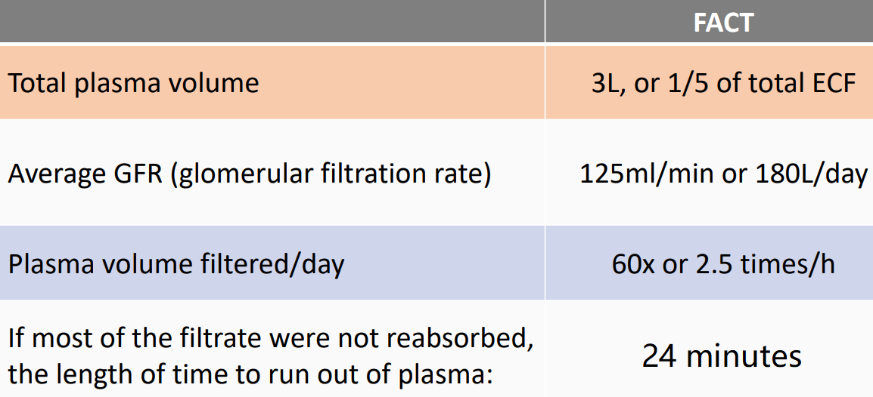Water and solutes are **non-discriminately filtered** at the **glomerulus**
* Structure
  + **Glomerular capillary wall** – vascular side
    - single layer of endothelial cells that’s more permeable to water and solutes
  + **Basement membrane** – in between
    - acellular gelatinous layer composed of collagen and glycoproteins
  + **Inner layer of Bowman’s capsule** – tubular side
    - podocytes (foot processes) encircle the glomerular tuft
* Pressure: 55 - 30 - 15 = **10 mmHg**

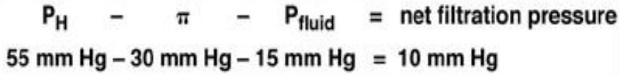

* + **Glomerular capillary blood pressure** (PH)
    - 55 mmHg, major force towards filtration
    - Caused by heart & efferent smaller than afferent (resistance diff.)
  + **Plasma-colloid osmotic pressure** ($π)$
    - -30 mmHg, opposes filtration
    - Caused by unequal distribution of plasma proteins across glomerular membrane
  + **Bowman’s capsule hydrostatic pressure** (Pfluid)
    - -15 mmHg, opposes filtration
    - Pressure exerted by fluid in initial part of tubule
* **Vasoconstriction of afferent** arteriole: ↑ resistance, ↓ renal blood flow (RBF), ↓ P­H and therefore GFR
* **Vasoconstriction of efferent** arteriole: ↑ resistance, ↓ renal blood flow (RBF), ↑ P­H and therefore GFR (higher pressure at glomerulus)
* **Unregulated** factors that affect GFR
  + Net filtration pressure (~10 mm Hg)
  + Glomerular **surface area** available for penetration
  + **Permeability** of the glomerular membrane
  + **Pathology**
    - **Dehydrating** diarrhea: loss of water > loss of electrolytes, plasma-colloid osmotic pressure ↑, GFR ↓
    - Severely burned: GFR ↑, reason unclear
    - **Obstructions** (kidney stone or enlarged prostate): GFR ↓, bowman’s capsule hydrostatic pressure ↑
* **Regulated** Control of GFR
  + **Extrinsic** sympathetic control (long-term regulation of arterial BP)
    - **Fight or flight**: SNS input to afferent arterioles of glomerulus
    - **Baroreceptor Regulation**: aortic and carotid, **long-term** regulation of arteriole blood pressure
    - **Cardiac Output to Kidneys**: major blood re-conditioning organ, receives ~25% of the cardiac output
  + **Intrinsic** / autoregulation(prevents spontaneous changes in GFR)
    - **Myogenic autoregulation**: arteriolar resistance adjusted locally for stable GFR, occur due to the myogenic properties of the arterioles (?)
    - **Tubuloglomerular feedback**: macula dense sense ↑ [NaCl], release adenosine, juxtaglomerular cells constrict afferent arteriole
      * **Juxtaglomerular apparatus**: final portion of ascending loop of Henle, passes between afferent and efferent arterioles
      * **Macula densa**: plaque of cells in tubule that detect changes in [NaCl], ↑ GFR result in ↑ [NaCl] in tubule, secrete paracrine
      * **Juxtaglomerular cells**: specialized smooth muscle in wall of afferent arteriole, adjacent to MD, alter diameter of afferent
    - GFR maintained between **80-180 mm Hg**
      * Within this range, changes in arterial pressure can be compensated for without disrupting GFR (i.e., consider exercise)

**Tubular Absorption and Secretion**

* 99% fluid reabsorbed
* 5 components
  + **Bowman’s capsule** (collects glomerular filtrate)
  + **Proximal tubule** (uncontrolled secretion/reabsorption)
  + **Loop of Henle** (establish osmotic gradient)
  + **Distal tubule** (controlled reabsorption)
  + **Collecting duct** (collect urine)
* 4 methods
  + **Filtration**: blood to lumen, **non-discriminate**
  + **Reabsorption**: lumen to blood, **selective**
  + **Secretion**: blood to lumen, **selective**
  + **Excretion**: lumen to external, **non-discriminate**
* 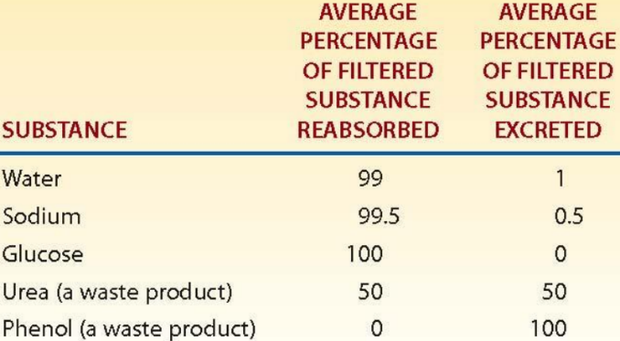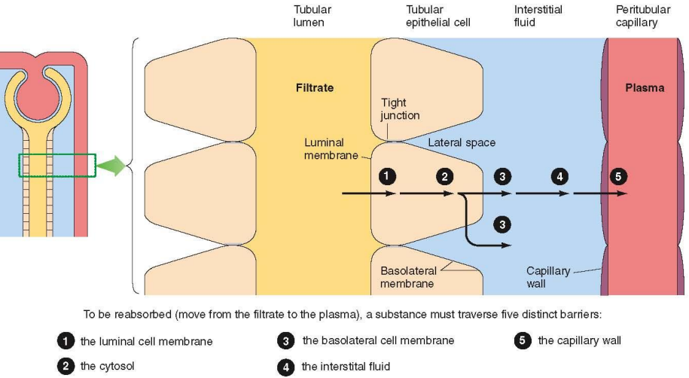**Reabsorption**: **transepithelial transport across 5 barriers**
  + **Luminal** membrane => cytosol => **basolateral** membrane => interstitial fluid => capillary wall
  + Passive & active
* **Sodium reabsorption**:
  + Na-K pump in basolateral membrane, 80% of kidney’s energy
  + 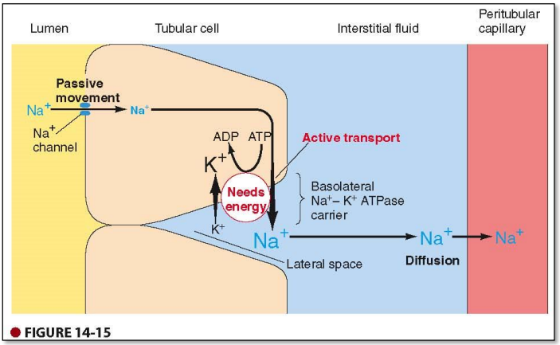Why majority of filtered Na+ need to be immediately reabsorbed?
  + **Proximal tube: 67%** Na reabsorbed, plays role in reabsorbing glucose, amino acids, H2O, Cl- , and urea
  + Descending loop of Henle: amount of Na reabsorption directly effects osmosis gradient & amount of water reabsorption (**↑ Na => ↑ water reabsorption**)
  + **Ascending loop: 25%** Na reabsorption (due to gradient after water reabsorption), ability to produce urine of varying concentrations
  + Distal tube and collecting duct: little (8%) Na reabsorption, variable and subject to hormonal control; plays role in regulating ECF volume
  + 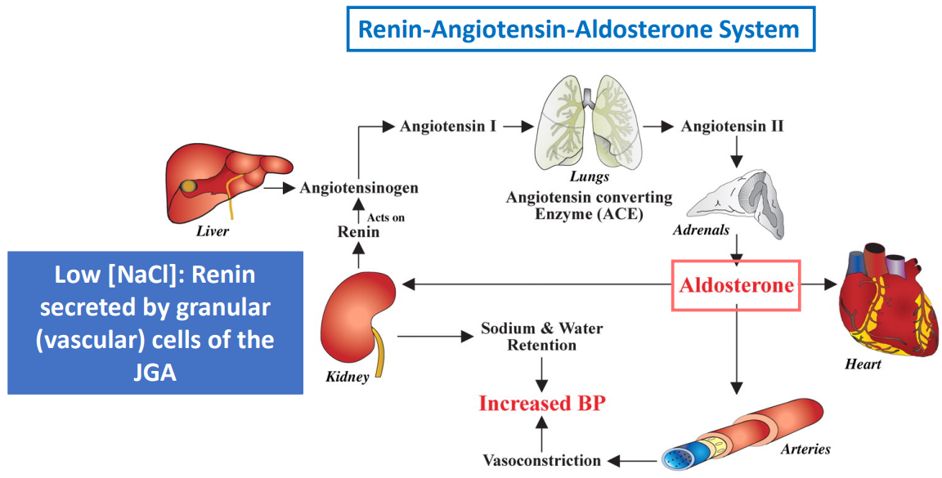Low Na concentration: **Renin-Angiotensin-Aldosterone** system
  + High Na: **Atrial Natriuretic Peptide (ANP)** inhibits Na+ reabsorption (also ↓ water reabsorption)

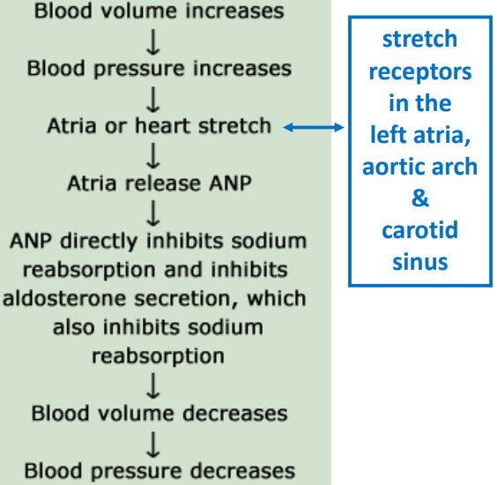

* 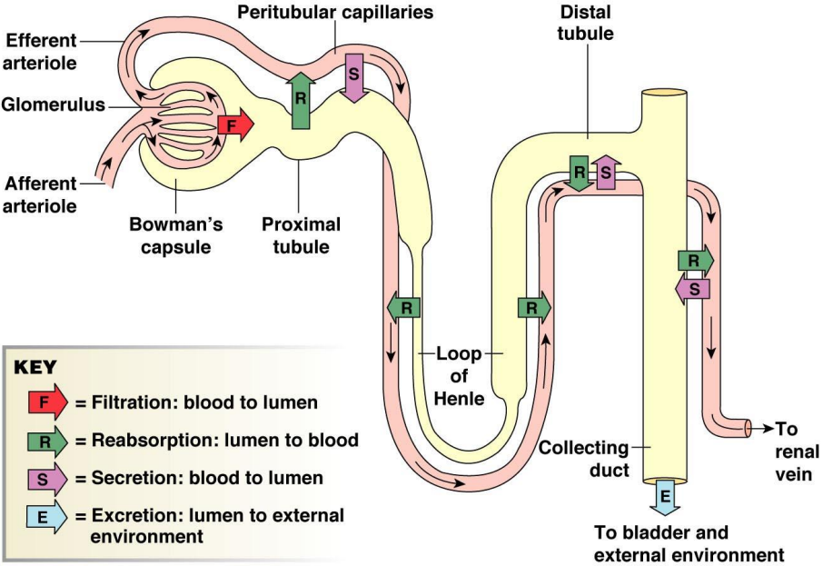**Secretion**: reverse of reabsorption (5 epithelial barriers), NOT in loop of Henle
  + **Secretion of K ions**: same Na-K pump that pumps Na+ out of epithelial cells pumps K+ into the cells, which passively moves into the lumen (tubule)
    - K+ is the most abundant solute inside cells (only ~ 2.5% outside the cells)
    - Most K+ is **reabsorbed** in the **proximal** tubule (67%) due to gradient
    - Similar to Na, **20% reabsorbed at ascending** loop (after water)
    - At the **distal tubule only 5-10%** of filtered load remains
      * Most often **secreted** at distal & collecting due to **Aldosterone**
    - Reabsorption of K is passive!
  + **Aldosterone**: simultaneous absorption of Na+ and secretion of K+
    - Plasma [K+ ] must be kept at appropriate levels for muscles & neurons

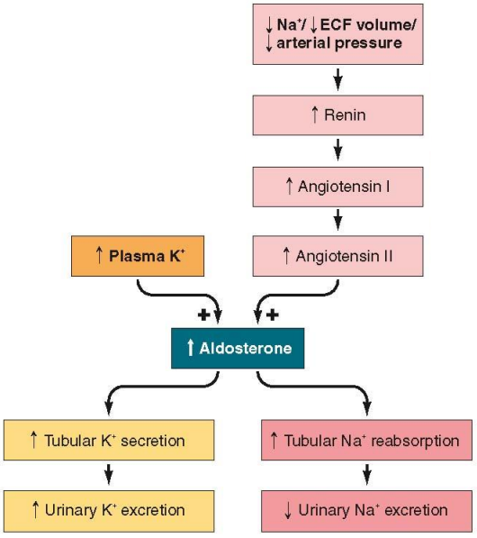

**Plasma Clearance**

* **Volume of plasma** required for excretion of a substance

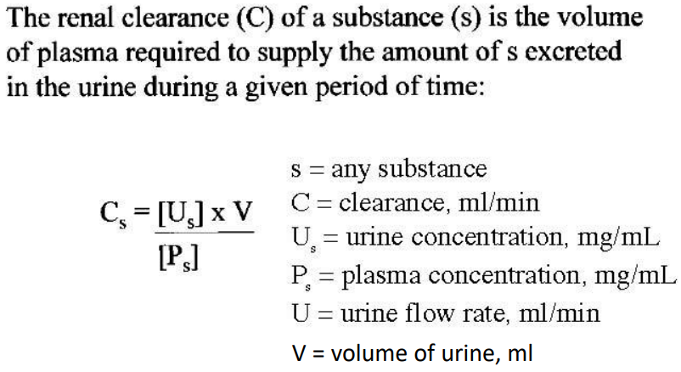

* **Inulin Clearance** is the “Gold Standard”
  + **Inulin**: Carbohydrate produced by Jerusalem artichokes
    - **\*Freely filtered and neither absorbed nor secreted**
    - Clinical means of determining GFR
    - If a substance’s clearance > inulin (> GFR), must be secreted
    - If a substance’s clearance < inulin, must be reabsorbed
      * Ex: **Glucose**, not secreted but **completely reabsorbed**

**Osmotic gradient & countercurrent mechanism**

* **Osmotic gradient**: established in the interstitial fluid of the medulla
  + Osmolarity: measures the amount of water
  + 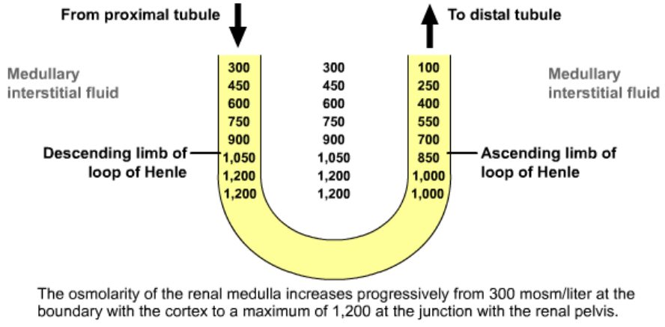Increase from 300 to 1200 mOsm/L follows the Loop of Henle down the medulla
* Descending loop only permeable to water (passive), ascending loop actively transport out Na and impermeable to water
* **Countercurrent**: between tubules, vessels, and between tubule and vessel
  + Only in juxtamedullary nephrons, vasa recta remove water from the ISF

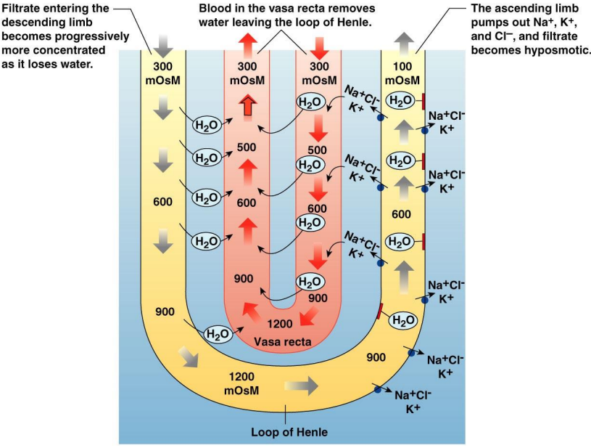

**Excretion of urine**

* **Micturition** **Reflex**: bladder **stretch receptors** => PNS (**parasympathetic**) => contract smooth muscle in bladder wall & relax external sphincters (under **voluntary** control)

**Diseases**

* **Urinary incontinence**: inability to voluntary control external sphincters
* **Renal** **Failure**
  + GFR decreases with age: 20% decrease is serious
* **Kidney Stones**
  + Too much salt intake => too little salt reabsorption => crystals form in kidneys
  + Treatment is dietary, shockwave, or surgery (ureteroscopy)